Filing Funnel Dashboard – Case Study
We start with loading the data to power Bi and transforming it. This is to ensure data quality and accuracy.

Data Transformation

List Price
Column list-price consists of wrong value like fifty,*,seventy and %, replacing the string numerical value to numerical value and other special character rows are removed
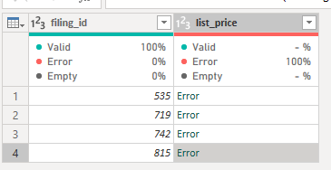
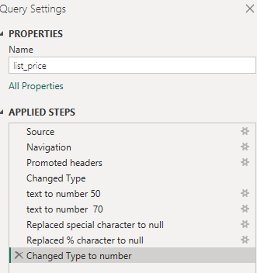

User Type
Replace blank value with unknown
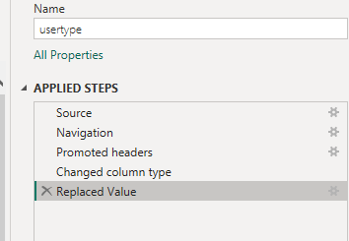

Revenue
Replacing the string numerical value to numerical value and negative value to absolute value
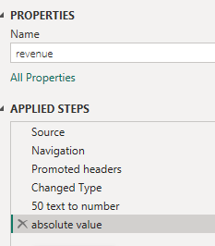

Fact-filling
We create one table combining filling start, filling end, revenue, user type and list price.
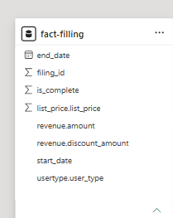

Model View
I used a simple star schema with one fact table and one date table.
- fact-filling (fact table): It has one row for each filing. I started from Filing Starts and joined Filing Complete, Revenue, User Type and List Price using filing_id. A filing counts as completed if it has a completion date (is_complete = 1).
- Dim_Date (date table): It covers Jan 2024 to Dec 2025. It has Date, Year, Month, Week Number, Day of Week and Week Start Date. It links to fact-filling with a one-to-many relationship on the start date. The filter goes from Dim_Date to the fact table.
- YoY and Benchmark_Period (slicer tables): These are not connected to the other tables. They only hold the slicer choices. YoY holds Day / Week and Benchmark_Period holds Last 2 Weeks / Trailing 12 Weeks. The measures read the selected value and change the calculation.
- Measure Table: It holds all the DAX measures in one place.
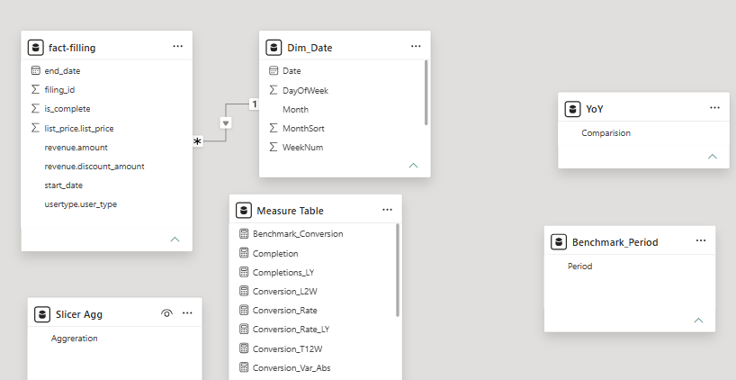

Assumptions
- This Year means the year selected in the date slicer (2025). Last Year is 2024.
- A filing is completed if it has a completion date. Completion rate = completed / started.
- Every completion happens on its start date, so I used the start date for everything.
- Rates are always calculated from totals, never by averaging rates.
- Blank user types are shown as Unknown. Text values in the price columns were converted to numbers where possible.
- Last 2 weeks and trailing 12 weeks are measured back from the last date in the selected range.

Date Logic
- Day: each date is compared with the same calendar date last year.
- Week: each date is compared with the same week number and weekday last year, so Monday is compared with Monday.
- The Comparison slicer switches between the two. The Date slicer filters the date table, so every visual updates together.
- Last 2 weeks is the last 14 days. Trailing 12 weeks is the 84 days before that, with no overlap.

Statistical Method
- I used a two-proportion z-test to compare completion rate this year with last year.
- Z = (p1 - p2) / sqrt( p x (1 - p) x (1/n1 + 1/n2) ), where p is the combined completion rate of both periods.
- If |Z| is 1.96 or more, the dashboard shows Significant (95% confidence). Otherwise it shows Not Significant.
- Daily comparisons have few filings each day, so I treat them as directional only.

Report View
The report is one dashboard page called Filling. It shows how many filings are started and completed, how the completion rate compares with last year, and whether the difference is real or just noise. The slicers are at the top, the KPI cards are below them, and the charts and table are at the bottom.

1. Slicers
- Date: A date range slicer. I use it to choose the period. For a year-on-year view I set it to 1 Jan 2025 to 31 Dec 2025, so 2025 is compared with 2024.
- Comparison: A dropdown with Day and Week. Day compares each date with the same calendar date last year. Week compares each date with the same week number and weekday last year.
- User Type: Buttons for Existing, New and Unknown. I can select one or more. Every number and chart on the page changes with this selection.

2. KPI Cards
- # of Filling Started: Total filings started in the selected period.
- # of Filling Completed: Total filings completed in the selected period.
- Completion TY %: Completion rate for the selected period (completed divided by started).
- Completion LY %: Completion rate for the same period last year.
- Completion TY vs LY %: The difference between the two rates, in percentage points. For example, 84.94% minus 84.70% is 0.24 points.
- Z Score: A statistical score for the difference between this year and last year. A bigger number, positive or negative, means the difference is less likely to be by chance.
- Significance: Shows Significant if the Z score is 1.96 or more (95% confidence), and Not Significant if it is below that. It shows Sample < 30 when there are too few filings to test.

3. Completion TY vs LY % (line chart)
This chart shows the completion rate over time. The solid line is this year and the dotted line is last year. I can drill from year to quarter, month and day. The two lines show whether this year is above or below last year at any point. The dotted line starts in 2025 because there is no 2023 data to compare with 2024.

4. Start and Completion by User Type (bar chart)
This chart shows how many filings were started and completed for each user type: Existing, New and Unknown. Existing users are the largest group. I can compare the gap between the two bars to see where more filings are dropped.

5. Filling Details (table)
The table shows the numbers behind the charts by quarter and year. It has filings started this year and last year, the variance in filings, the completion rate this year and last year, and the difference in percentage points. The Total row sums the whole selection.

6. Completion % (Last 2 Weeks vs Trailing 12 Weeks)
This chart compares the completion rate in the last 2 weeks (the last 14 days) with the 12 weeks before that (84 days, no overlap). It shows whether recent performance is moving away from the normal level.

Dashboard View


